EXPT NO:2 | Implementation of data visualization techniques
DATE: 06.01.2026 | Implementation of data visualization techniques

PRE-LAB QUESTIONS (PROVIDE BRIEF ANSWERS TO THE FOLLOWING QUESTIONS)
- Why is exploratory data analysis critical before model building?
Answer: EDA allows analysts to understand data structure, identify missing values, and detect anomalies. This prevents "Garbage In, Garbage Out" errors and ensures the data is suitable for the chosen machine learning algorithms.
- How do distributions influence algorithm selection in ML?
Answer: Many algorithms, such as Linear Regression and Gaussian Naive Bayes, assume data follows a normal (bell curve) distribution. If the data is skewed, we must either transform it or select non-parametric algorithms like Decision Trees that handle skewness well.
- What insights can outliers provide in business data?
Answer: Outliers often represent significant business events. In e-commerce, high-value outliers might indicate VIP customers ("whales") worth retaining, while low-value or repetitive outliers could signal fraudulent transactions or system errors.
- Why are visual summaries preferred over raw tables?
Answer: Visuals leverage the human brain's ability to process patterns multiple times faster than text. They reveal trends, clusters, and correlations instantly that would be impossible to spot in a spreadsheet with thousands of rows.
- How does visualization improve business intelligence?
Answer: Visualization transforms complex datasets into intuitive dashboards. This allows non-technical stakeholders to monitor Key Performance Indicators (KPIs) in real-time, facilitating faster, evidence-based decision-making without needing to query databases manually.

IN-LAB EXERCISE:
OBJECTIVE:

To explore data distribution and variability using advanced visualization techniques.
SCENARIO:
A startup analyzes e-commerce transaction data to understand customer spending behavior and detect abnormal purchase patterns.

IN-LAB TASKS (Using R Language)
- Plot histogram of transaction amounts
- Use boxplot to detect outliers
- Create heatmap of monthly sales intensity

CODE:
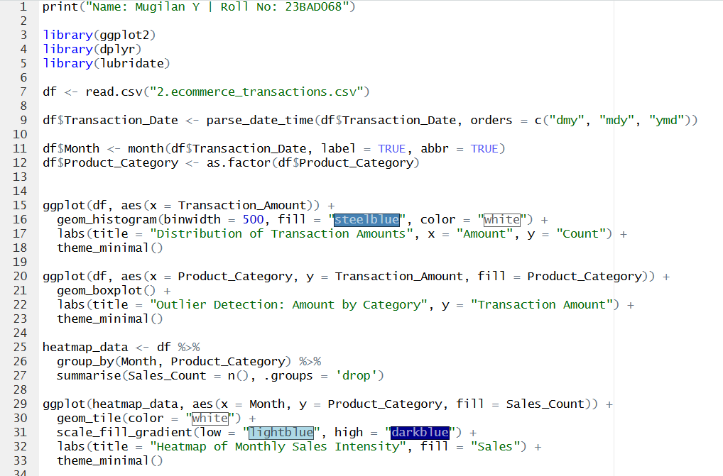

OUTPUT:
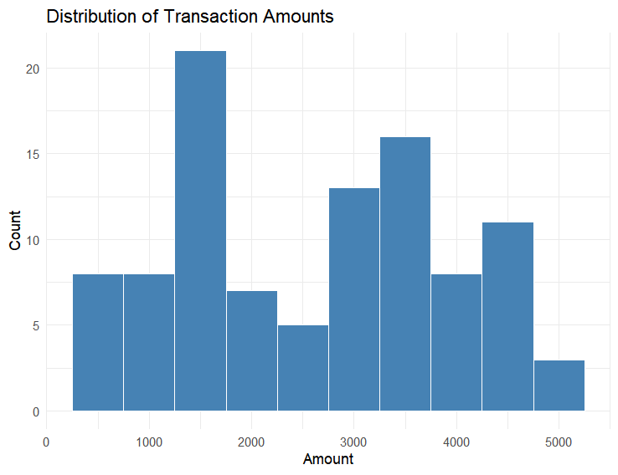
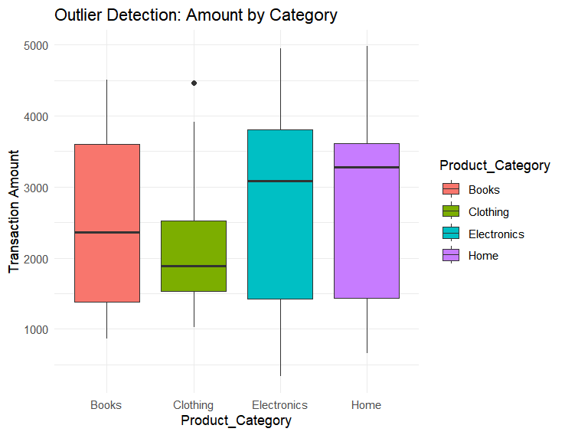
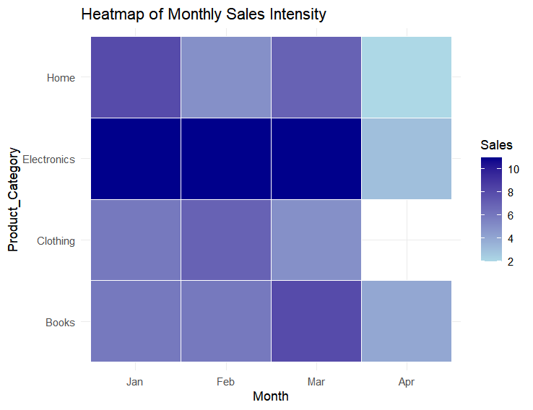
POST-LAB QUESTIONS (PROVIDE BRIEF ANSWERS TO THE FOLLOWING QUESTIONS)
- What does right-skewed distribution indicate about customer behavior?
Answer: It indicates that most customers make small, low-value purchases, while a very small number of customers make high-value purchases. This is known as the "Long Tail" effect in retail.
- How can detected outliers impact business decisions?
Answer: Outliers signal anomalies. For example, the Boxplot detected a high-value outlier in the Clothing category. Business-wise, this could represent a VIP customer (a "whale") to target for loyalty programs, or potentially a data entry error to investigate.
- Which visualization best supports anomaly detection?
Answer: The Boxplot is best for this because it statistically defines the "normal" range (whiskers) and explicitly isolates anomalies as individual dots (like the one seen in the Clothing category).
- How does EDA improve AI model accuracy?
Answer: EDA identifies skewed distributions and outliers early. This allows data scientists to clean the data (e.g., removing extreme outliers) or apply transformations (like log-scaling) so that AI models aren't biased by noise.
- How can visualization guide feature engineering?
Answer: Visualizations reveal hidden patterns. For instance, the Heatmap shows high sales intensity for "Electronics" in the first three months. This suggests creating a feature like Is_Peak_Season to help the AI model predict future sales spikes more accurately.

ASSESSMENT
Description | Max Marks | Marks Awarded
Pre Lab Exercise | 5
In Lab Exercise | 10
Post Lab Exercise | 5
Viva | 10
Total | 30
Faculty Signature

